1. 
2. **Agenda**: Writing your first test in POSTMAN.
3. **Test:** Just an assertion.
   1. In the assertion, we check a value from the response against an expected value.
   2. One request can have multiple tests and one test can have multiple assertions.

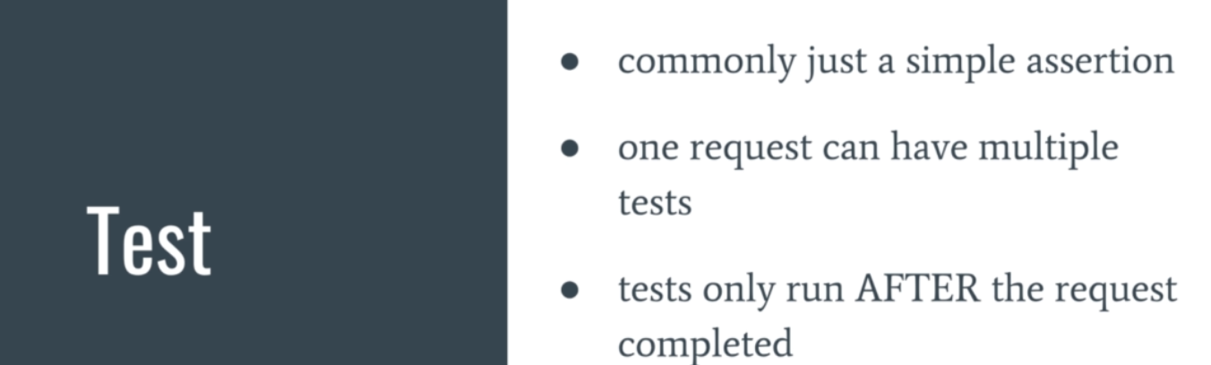

1. 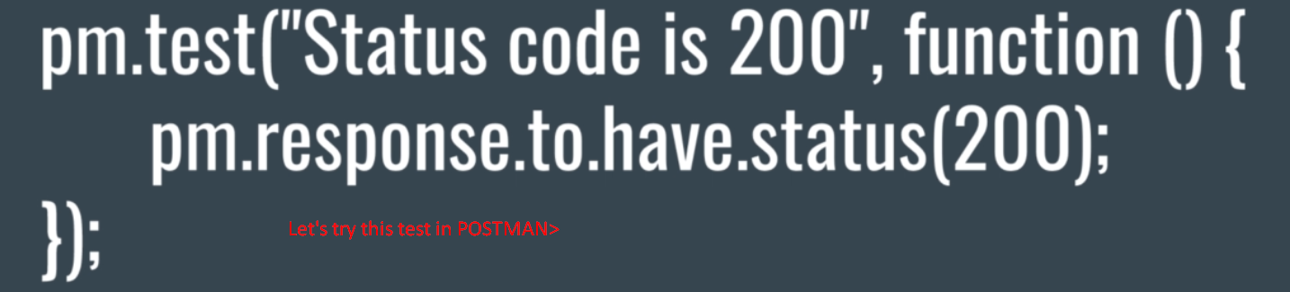
2. 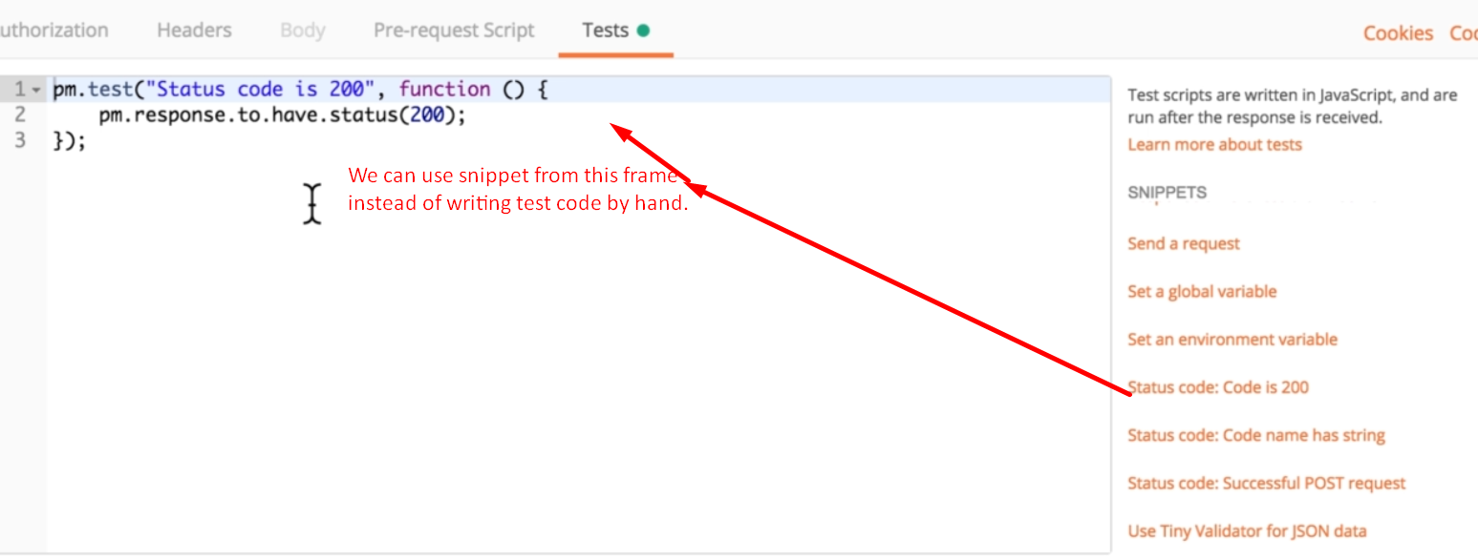
3. 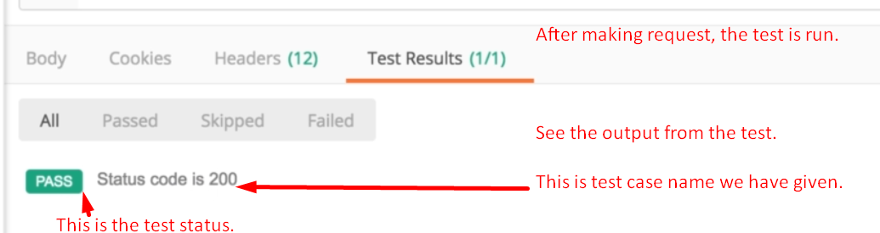
4. Let’s write test that actually fails.   
   Actually, we should write those tests too which get failed and most testers and developers don’t write such test cases.  
   
5. 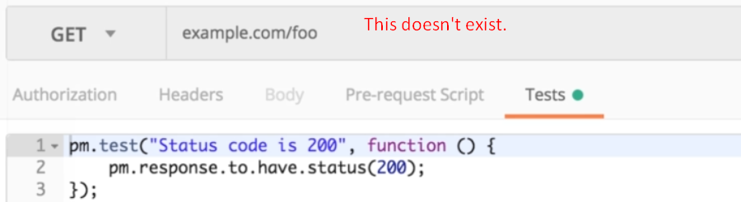
6. 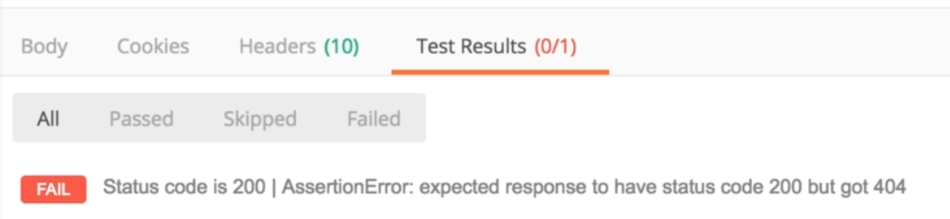
7. Let’s try to understand what exactly is happening in here.
8. 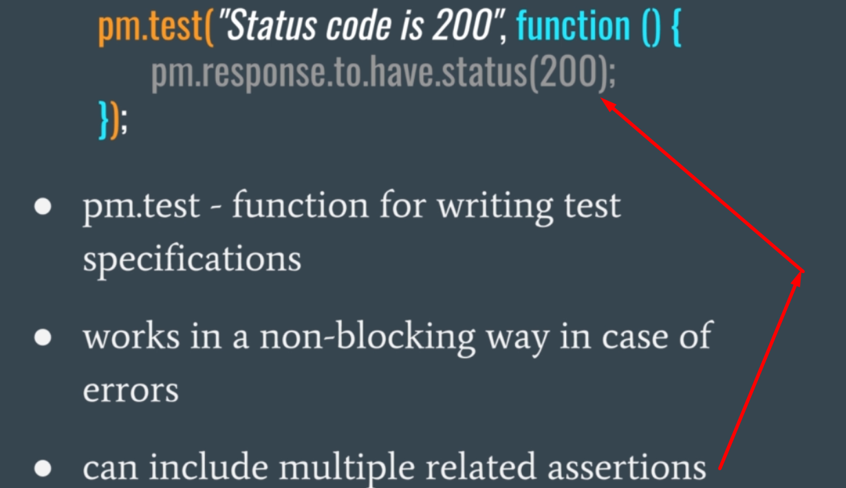
   1. **pm.test**(): This is the function being called all the time when writing test cases.
   2. **Advantage**: If any error inside pm.test(), the error would not block the other test cases as that code would be wrapped inside the pm.test() function.
9. 